**Project Goal, Simplified**

**Our Simple Goal: Get More Bang for Our Buck**

The entire point of this project is to figure out exactly **where to spend our advertising money** to get the most customers.

Right now, we're spending a lot of money (high Customer Acquisition Cost, or **CAC**) on ads that don't always work. We're going to use this data to build a smart system that helps us stop wasting money on bad clicks and focus all our effort on the users who are most likely to buy our product.

**The Business Problem (What We're Trying to Solve)**

**The Big Challenge: Wasting Money on the Wrong People**

We're running many ads—on Facebook, Google, other websites—but we don't truly know **which ad and which person is worth the most investment**. It’s like throwing darts in the dark.

* **The Cost Problem:** Our current ads are expensive because too many people click but never buy anything. This makes our overall customer cost too high.
* **The Intelligence Gap:** We can see *how many* people bought something (*reporting*), but we can't tell the marketing team *which new person* is about to buy (*predicting*).

**Assumptions**

### The Trend of Future Data Will Also Be Same.

**The Technical Term:** We call this **Data Stability** or **Non-Drift**.

**Simplified Takeaway:** **"What worked yesterday will keep working tomorrow."** If our target audience dramatically changes their online habits, the model will need to be re-trained.

### We Must Keep All Features on Which Model Will Be Trained.

**The Technical Term:** This is a **Deployment Dependency**.

**Simplified Takeaway:** **"If the model needs a piece of information, we must guarantee we can collect it for every new person."** No missing information is allowed for making a prediction.

* 1. **The Data Accurately Represents the Real Customer.**

### We Have the Ability to Act on the Prediction

**The Assumption:** The marketing team *can* adjust their ad spend or targeting in real-time (or near real-time) based on the model’s prediction.

## Marketing and Conversion Hypotheses

* **Demographic Hypothesis:** Clients who successfully convert (Conversion = Yes) will predominantly belong to the **Age** group of less than 18 and will be mostly **female**.
* **Conversion Efficiency Hypothesis:** The overall **Conversion Rate** (Conversions divided by Clicks) is expected to be greater than 50% of the **Click-Through Rate** (Clicks divided by Views).
* **Channel Performance Hypothesis:** The **Social Media** channel is expected to account for the majority of successful conversions, either in raw count or as a percentage of clicks for that channel.
* **Email Engagement Hypothesis:** Customers whose volume of **Previous Purchases** is above the dataset's average are the same group of customers who actively register **Email Clicks**.
* **Loyalty Hypothesis:** There is a **direct, positive correlation** between accumulating a high number of **Loyalty Points** and achieving a positive conversion outcome (Conversion = Yes).
* **Ad Quality Hypothesis (Inverse Relationship):** Campaigns that exhibit an extremely high **Click-Through Rate** are expected to correlate with a subsequent **low Conversion Rate**, suggesting that the audience clicking the ad is of poor quality.
* **Engagement Hypothesis (Behavioral):** Converting customers (Conversion = Yes) will display significantly higher engagement metrics, specifically in their **average Time on Site** and **Pages Per Visit**, compared to customers who do not convert.

## Research Questions

### I. Customer Segmentation & Performance

1. Which **Gender** segment exhibits the **highest Conversion Rate**?
2. Which **Gender** segment exhibits the **highest Click-Through Rate**?
3. Which **Age Group** exhibits the **highest Conversion Rate**? (Age Groups Teenager(18 to less than 21), Young (21 to less than 50), Old (50 and above)).
4. Which **Age Group** exhibits the **highest Click-Through Rate**?
5. Which **Income Group** exhibits the **highest Conversion Rate**? (Income Groups: Lower-Class (≤25% percentile), Middle-Class (≤50% percentile), Upper-Class (≤75% percentile), Elite-Class (>75% percentile)).
6. Which **Income Group** exhibits the **highest Click-Through Rate**?

### II. Campaign and Channel Effectiveness

1. Which **Campaign Channel** has the **top highest Click-Through Rates**?
2. Which **Campaign Channel** has the **top highest Conversion Rates**?
3. Which **Campaign Channel** has the **lowest Click-Through Rates**?
4. Which **Campaign Channel** has the **lowest Conversion Rates**?
5. Which **Campaign Type** has the **top highest Click-Through Rates**?
6. Which **Campaign Type** has the **top highest Conversion Rates**?
7. Which **Campaign Type** has the **lowest Click-Through Rates**?
8. Which **Campaign Type** has the **lowest Conversion Rates**?

### III. Top/Lowest Customer Behavioral Metrics

1. Who are the **top 10 customers** with the **highest** values for each of the following behavioral metrics: **Website Visits**, **Pages Per Visit**, **Time On Site**, **Social Shares**, **Email Opens**, **Email Clicks**, **Previous Purchases**, and **Loyalty Points**?
2. Who are the **top 10 customers** with the **lowest** values for each of the following behavioral metrics: **Website Visits**, **Pages Per Visit**, **Time On Site**, **Social Shares**, **Email Opens**, **Email Clicks**, **Previous Purchases**, and **Loyalty Points**?
3. Which are the **top 10 customers** with the **highest volume of Previous Purchases**?
4. Which are the **top 10 customers** with the **lowest volume of Previous Purchases**?

### IV. Correlation Analysis

1. What is the correlation between **Income** and **Conversion Rate**?
2. What is the correlation between **Income** and **Click-Through Rate**?
3. What is the correlation between **Ad Spend** and **Conversion Rate**?
4. What is the correlation between **Ad Spend** and **Click-Through Rate**?
5. What is the correlation between **Email Opens** and **Email Clicks**?
6. What is the correlation between **Time On Site** and **Loyalty Points**?

### Essential ML/Classification Questions

1. **Model Performance:** What is the performance of the final classification model (e.g., Precision, Recall, F1-Score, and AUC) on unseen data, and does it meet the business requirement for accuracy?
2. **Misclassification Analysis:** Where does the model fail? Which customer segments or behavioral profiles are most frequently **misclassified** (e.g., predicted to convert but do not, or vice versa)?

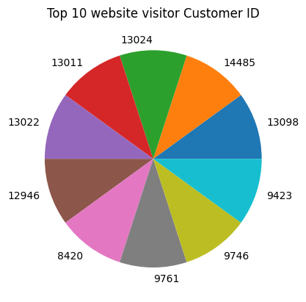

This pie chart shows the CustomerIDs of top customers. I have to mention customer ids as you don’t provided me the names of customers due to security of data.

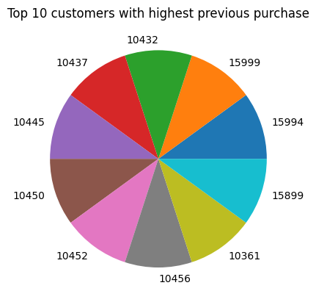

This pie chart shows top 10 customers with highest previous purchase where each top 10 has equal 9 purchases

**Model Insights and Findings**

**Low Linear Correlation:** The analysis confirms a weak or non-existent *linear* relationship between most numerical features. This justifies using a non-linear model (like Decision Tree/Random Forest) over simpler linear methods (like Logistic Regression).

The convergence rate is independent of age, gender and income group.

**Channel Homogeneity:** All primary campaign channels and types exhibit remarkably similar performance metrics (approx 10.4% Conversion Rate and approx 15% Click-Through Rate). This suggests a need for deeper segmentation, as no single channel currently offers a superior efficiency edge.

**Data Imbalance Management:** The primary modeling challenge was the severe class imbalance in the target variable. Future work requires more advanced techniques (e.g., SMOTE, ADASYN) or dedicated cost-sensitive learning to ensure robust performance on the minority (Conversion = Yes) class.

**High Accuracy but Misleading:** The Decision Tree classifier achieved $97\%$ overall accuracy on the test set. However, due to severe data imbalance, this high score is potentially misleading and requires validation using Precision, Recall, and F1-Score on the minority class.

**Model Insights and Information**

The model has accuracy of 97% on unseen data.

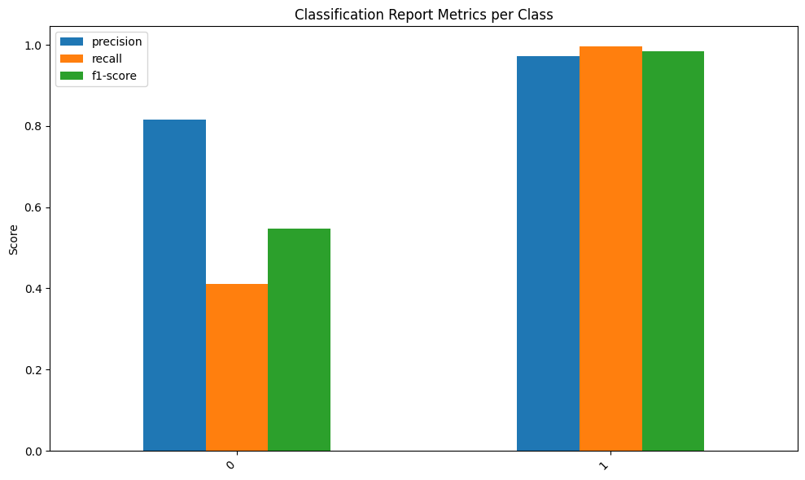

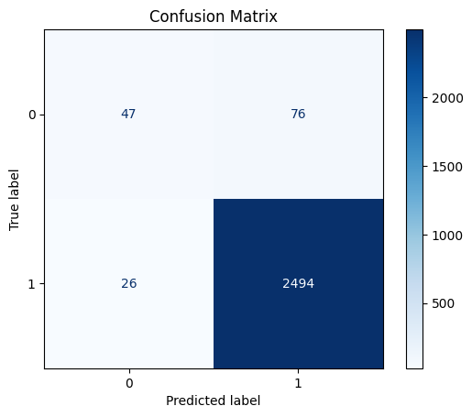

These graphs prove that while the classification model demonstrates a strong 97% accuracy, further analysis is required, as performance metrics are heavily influenced by the underlying data imbalance.

## Model Development Challenges

* **Model Selection Difficulty:** Initial attempts using Logistic Regression, Random Forest, and Decision Tree all returned high overall accuracy but suffered from unsatisfactory Precision, Recall, and F1-Scores due to the imbalanced data. The Decision Tree was selected as the best performing among the initial set.
* **Data Volume:** The small dataset size ($\approx 8,000$ rows) limits the complexity of the models and the depth of feature engineering, making it challenging to identify complex, non-obvious correlations.
* **Feature Understanding:** A lack of clarity regarding the correlations between features hindered preliminary data analysis, necessitating a reliance on automated model selection to reveal feature importance.

**Hypothesis Testing**

**"None of our original beliefs about our customers or ad performance were proven right.** We need to throw out our old assumptions and let the machine learning model show us the *real* customer profile."